Epoka University
Department of Computer Engineering

Course Name: Computer Networks
Course Code: CEN 307

Project Title:

“Virtual Networking and Client-Server Architecture Application Deployment”

Group Number: 22

Submitted By:

- Student 1 Name: Sidrit Rrustemi

- Student 2 Name: Viola Zeneli

- Student 3 Name: Arsildo Veliu

- Student 4 Name: Megi Almadhi

- Student 5 Name: Artemisa Hasalami

Submission Date: 30/01/2026

Instructor: Shkumbin Fida

Table of Contents

1. Deploy a Virtual Network NAT Network Using VirtualBox 4
2. Install Guest OS Hosts on VirtualBox and Configure Networking 5
2.1 Ubuntu Server: 5
2.1.1 Install Ubuntu Server and set hostname group22-02 during installation 5
2.1.2 Configure the connected network interface to use DHCP 7
2.1.3 Configure DNS on the network interface connected to NAT Network 8
2.2 Ubuntu Desktop: 8
2.2.1 Install Ubuntu Desktop and set hostname group22-01 during installation 8
2.2.2 Configure DNS on the network interface connected to NAT Network 10
3. Install Client Server Applications 11
3.1 On Ubuntu Server (group22-02): 11
3.1.1 Install Nginx Web Server on Apache Web Server 11
3.1.2 Ensure OpenSSH Server is installed 11
3.2 On Ubuntu Desktop (group22-01): 12
3.2.1 Install Google Chrome or Mozilla Firefox 12
3.2.2 Install the OpenSSH Client 12
4. Test Network Connectivity Between Hosts 13
4.1 Verify IP addresses on both Ubuntu Desktop and Server using ip a or ifconfig 13
4.2 Test local connectivity: 14
4.2.1 Ping group22-02 host from group22-01 host 14
4.2.2 Ping group22-01 host from group22-02 host 14
4.3 Test external connectivity using public hosts/web site using ping and traceroute 15
4.3.1 Ping a public host from group22-01 host 15
4.3.2 Run traceroute to a public host/web site from both hosts 16
4.4 Perform DNS resolution using nslookup using public DNS server on your chosen hostname or web site 17
4.5 Use the OpenSSH client to connect remotely from Ubuntu Desktop to Ubuntu Server 18
4.6 Assign static IP addresses to both Ubuntu Desktop and Ubuntu Server and repeat steps 4.2 and 4.3 19
4.7 Map Ubuntu Server hostname with IP (simulate local DNS) on for Ubuntu Desktop on /etc/hosts configuration file 24
5. Test Client Server Applications 25
5.1 From Ubuntu Desktop, access the default Nginx/Apache web page on Ubuntu Server via IP or hostname 25
5.2 Use the OpenSSH client on Ubuntu Desktop to connect to the OpenSSH server on Ubuntu Server via IP or hostname 26
6. Install Networking Tools 27
6.1 On Ubuntu Server install: 27
6.1.1 net-tools 27
6.1.2 iperf3 27
6.2 On Ubuntu Desktop install: 28
6.2.1 speedtest-cli 28
6.2.2 curl 28
6.2.3 Wireshark 29
7. Measure Performance and Document Results 30
7.1 Measure throughput 30
7.1.1 Between Ubuntu Desktop and Speedtest.net server using speedtest-cli or web browser 30
7.1.2 Between Ubuntu Desktop and Ubuntu Server using iperf3 or netperf 30
7.2 Measure Round Trip Time (RTT): 31
7.2.1 Between Ubuntu Desktop and Ubuntu Server 31
7.2.2 Between both hosts and a chosen public host 31
7.3 Use Wireshark to capture: 32
7.3.1 HTTP request/response packets between Ubuntu Desktop and Server 32
7.3.2 DNS packets between Ubuntu Desktop and your chosen public website 32
7.3.3 A TCP three-way handshake between Ubuntu Desktop and Server 33
7.4 Use curl on Ubuntu Desktop to send an HTTP GET request to the Nginx/Apache server on Ubuntu Server 33
8. Document the Project 34
8.1 For each task, explain concepts and terms from Computer Networks 34
8.2 Include screenshots to document all configurations and tests 36
8.3 Use Cisco Packet Tracer to illustrate your network topology, including router, switch, and end-host configurations 36
9. Final Conclusion 37

1

Deploy a Virtual Network NAT Network Using VirtualBox

A VirtualBox NAT Network was created to provide a private virtual LAN for all project virtual machines. The NAT Network is named group22_nat and is configured with the subnet 222.22.22.0/24, where /24 corresponds to the subnet mask 255.255.255.0. This configuration allows up to 254 usable host IP addresses within the same network segment.
DHCP is enabled on the NAT Network, allowing virtual machines to automatically receive IP configuration parameters, including IP address, subnet mask, default gateway, and DNS server. The NAT Network is then started, activating the virtual router functionality that enables both internal communication between virtual machines and external connectivity to the Internet through Network Address Translation (NAT).

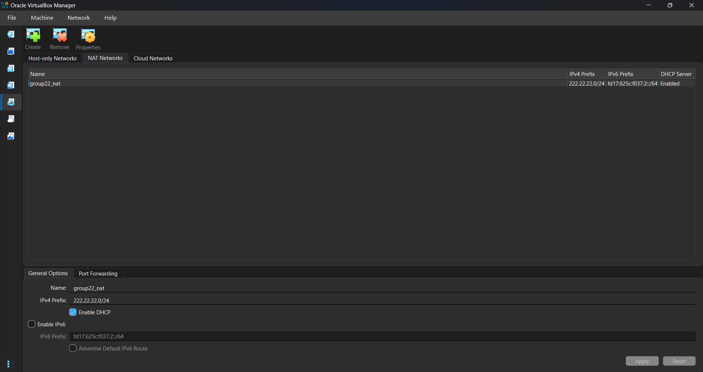

2

Install Guest OS Hosts on VirtualBox and Configure Networking

2.1 Ubuntu Server:

2.1.1 Install Ubuntu Server and set hostname group22-02 during installation
The Ubuntu Server virtual machine is created in VirtualBox using the Ubuntu Server installation image. Ubuntu Server is selected because it provides a lightweight, service-oriented operating system suitable for hosting network services such as web and SSH servers.
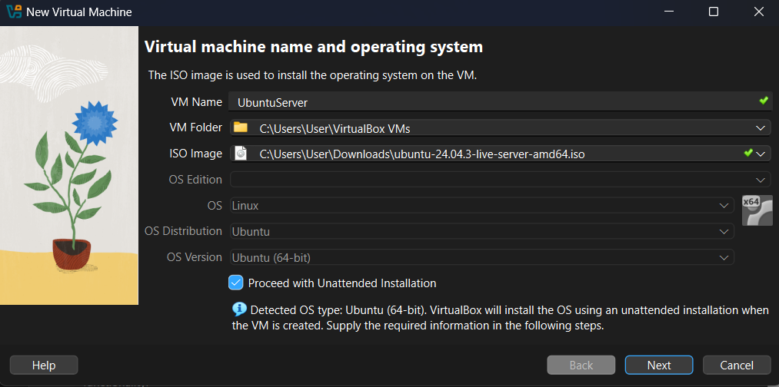
The virtual machine hardware is configured with 4096 MB of RAM, 2 virtual CPUs, and a 25 GB virtual disk. These resources ensure adequate performance for running server-side network services without bottlenecks.
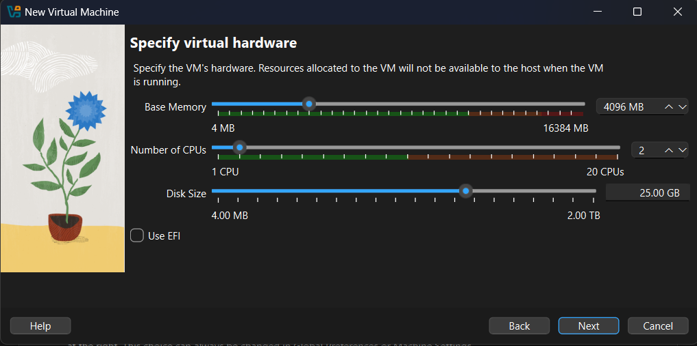
The Ubuntu Server installation process is initiated. This step installs the core operating system components required for server functionality, without a graphical interface, which reduces resource consumption and improves efficiency.
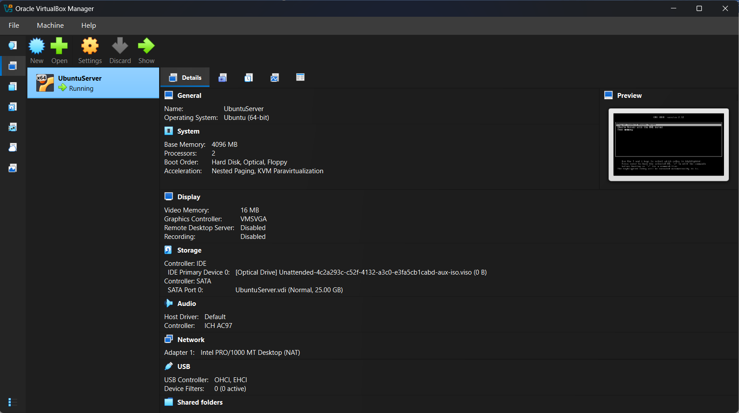

During installation, the system hostname is configured as group22-02, and a local user account named group22 is created. The hostname uniquely identifies the server within the network and is later used for hostname-based communication and management.
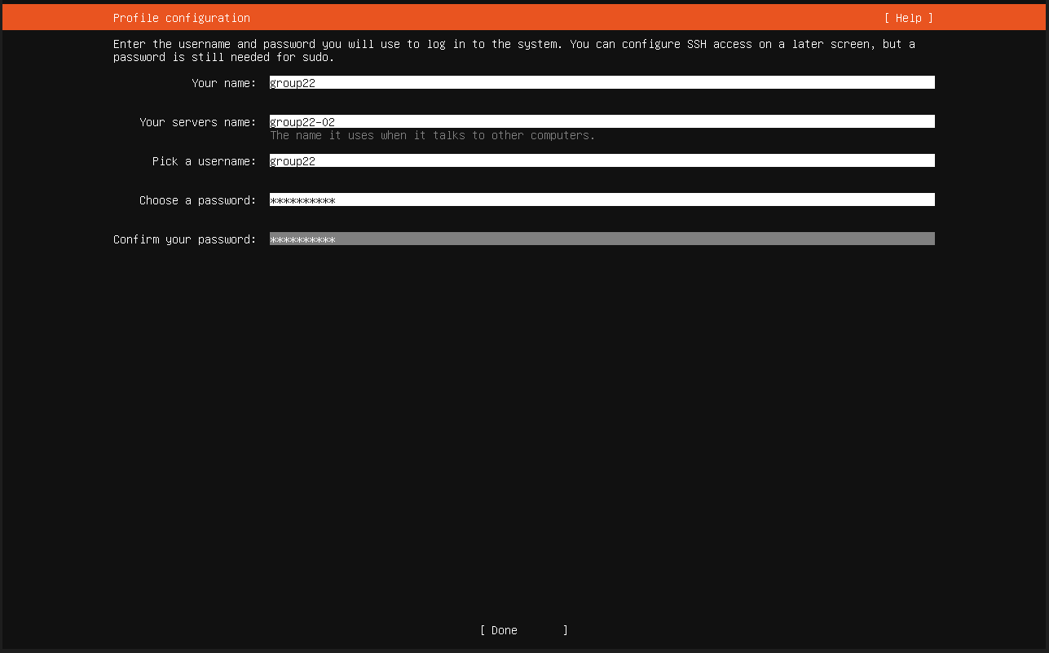
After installation completion, the system boots successfully and displays the active network interface enp0s3, confirming that the server is operational and ready for network configuration and service deployment.
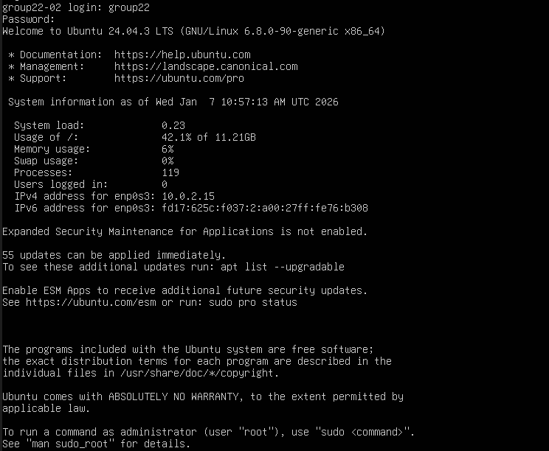

2.1.2 Configure the connected network interface to use DHCP
The Ubuntu Server network adapter is attached to the NAT Network group22_nat. This ensures that the server participates in the predefined subnet 222.22.22.0/24 and can communicate with other virtual machines connected to the same NAT Network. With DHCP enabled, the server automatically receives its network configuration.
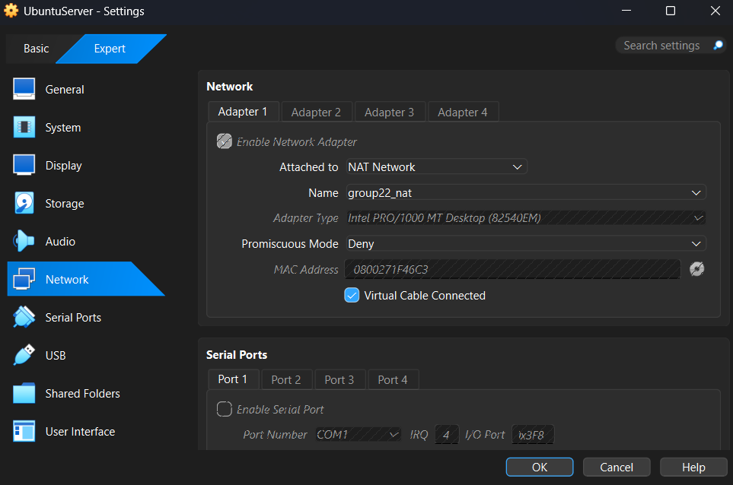

2.1.3 Configure DNS on the network interface connected to NAT Network
The network configuration file /etc/netplan/50-cloud-init.yaml specifies that the interface enp0s3 uses DHCP for IPv4 addressing. DNS servers are explicitly configured as 8.8.8.8 and 8.8.4.4, which are Google Public DNS servers. This configuration enables the server to resolve domain names into IP addresses, which is required for accessing external hosts and services using domain names.
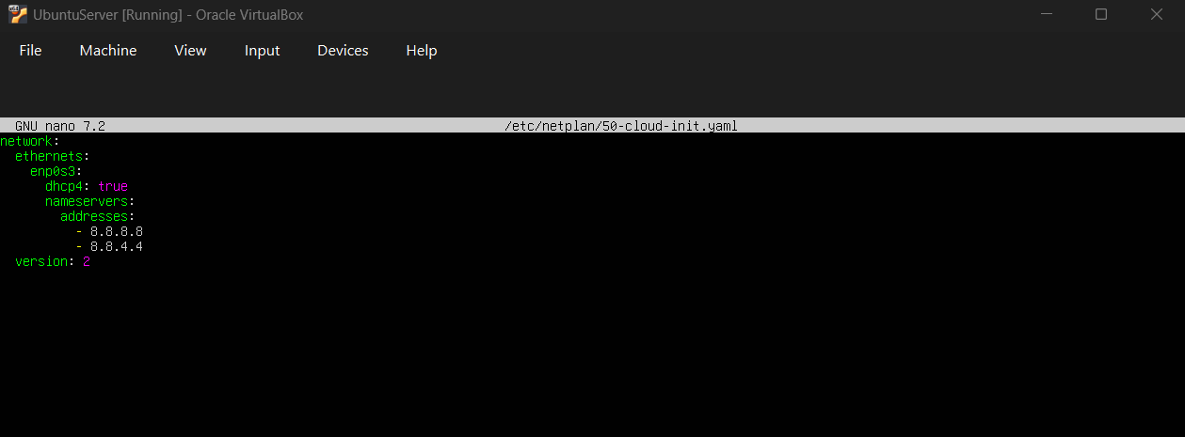

2.2 Ubuntu Desktop:

2.2.1 Install Ubuntu Desktop and set hostname group22-01 during installation
The Ubuntu Desktop virtual machine is created using the Ubuntu Desktop installation image and connected to the NAT Network group22_nat. Ubuntu Desktop provides a graphical user interface required for client-side tools such as web browsers and packet analysis software.
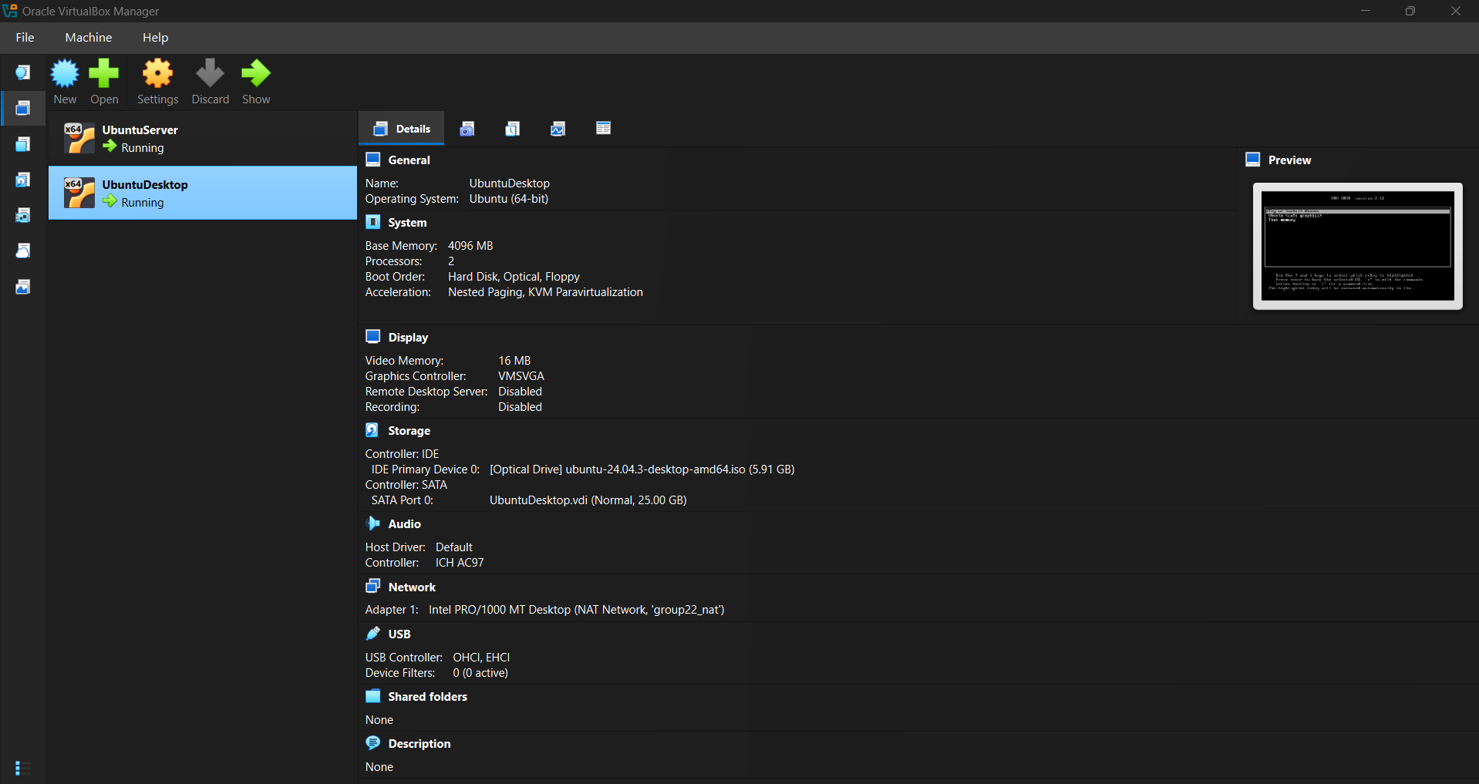
The Ubuntu Desktop installation environment is loaded, allowing system installation with a graphical interface suitable for end-user interaction.
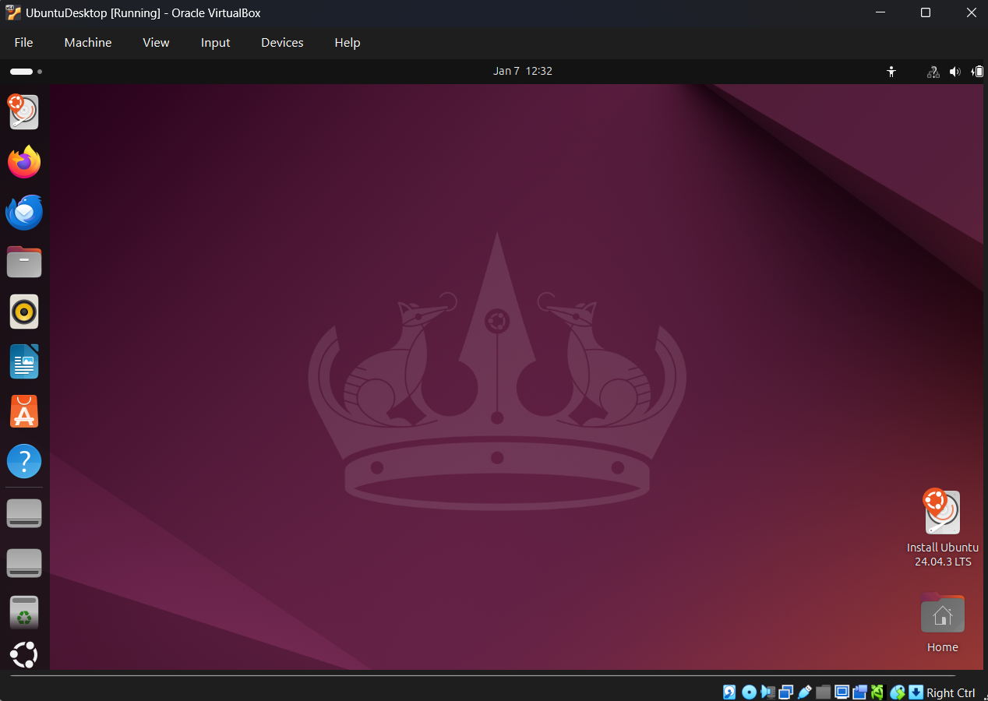
During installation, the hostname is set to group22-01, and the user account group22 is created. The hostname distinguishes the client machine from the server within the same network.
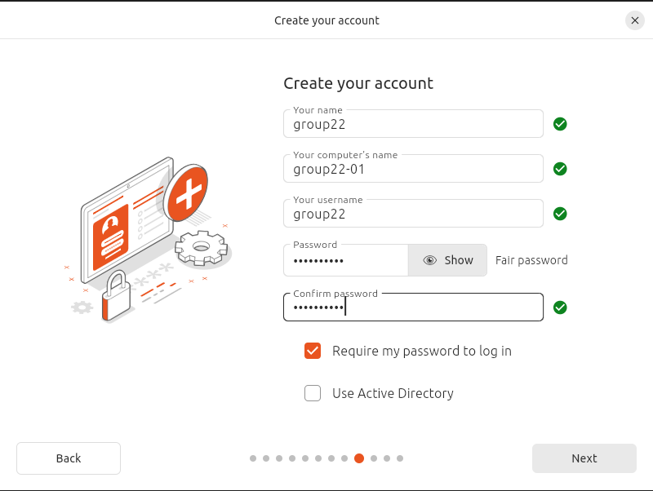

2.2.2 Configure DNS on the network interface connected to NAT Network
The network adapter is confirmed to be attached to the NAT Network group22_nat, ensuring the desktop system is placed in the same subnet as the server for direct communication.

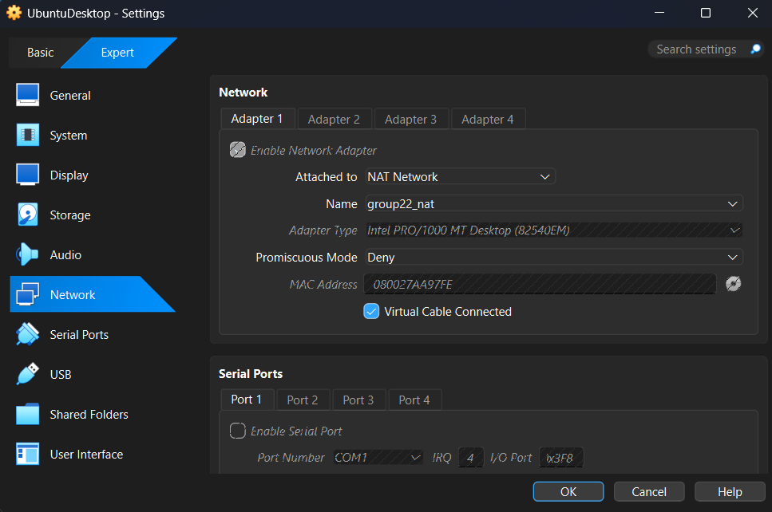

3

Install Client Server Applications

3.1 On Ubuntu Server (group22-02):

3.1.1 Install Nginx Web Server on Apache Web Server
The Nginx web server service is installed and verified as active and running. Nginx functions as the HTTP web server, listening for incoming HTTP requests on TCP port 80 and responding with web content. This server represents the application-layer service provider in the client–server architecture implemented in this project.
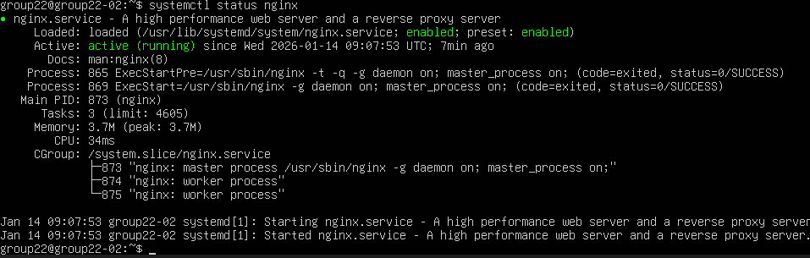

3.1.2 Ensure OpenSSH Server is installed
The OpenSSH server service is started and enabled to run automatically at system boot. OpenSSH provides secure remote access to the server using the SSH protocol, which operates over TCP port 22 and ensures encrypted communication between client and server.
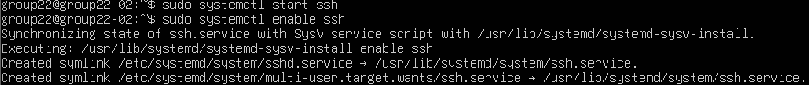

3.2 On Ubuntu Desktop (group22-01):

3.2.1 Install Google Chrome or Mozilla Firefox
The Firefox web browser is installed and verified as the latest available version. The browser functions as the HTTP client, sending HTTP requests to the web server and receiving HTTP responses that are rendered for the user.
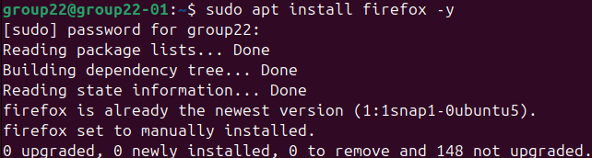

3.2.2 Install the OpenSSH Client
The SSH client utility is available on the Ubuntu Desktop system. This client initiates SSH connections to remote servers, enabling secure command-line access to the Ubuntu Server.
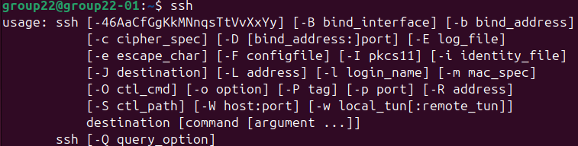

4

Test Network Connectivity Between Hosts

4.1 Verify IP addresses on both Ubuntu Desktop and Server using ip a or ifconfig
The network interface enp0s3 on the Ubuntu Desktop is assigned the IP address 222.22.22.6/24 via DHCP. The broadcast address is 222.22.22.255, confirming the system is correctly configured within the subnet 222.22.22.0/24.
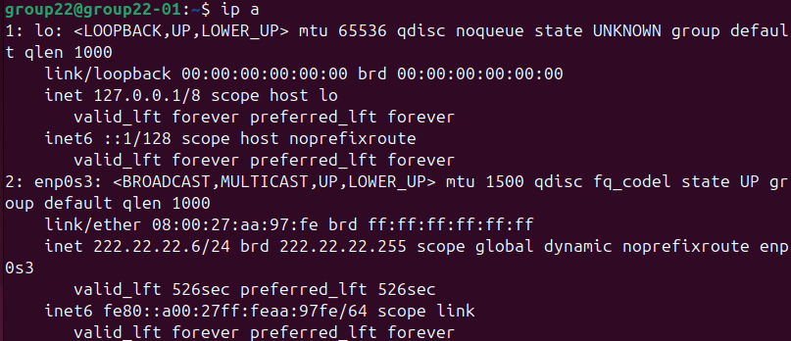

The network interface enp0s3 on the Ubuntu Server is assigned the IP address 222.22.22.5/24, also via DHCP. This confirms both hosts reside in the same Layer-3 network and can communicate directly.
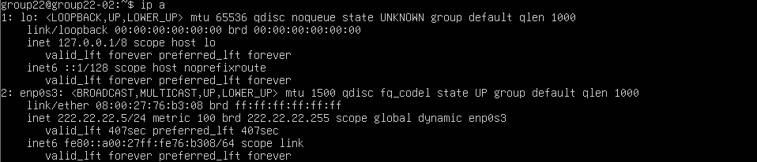

4.2 Test local connectivity:

4.2.1 Ping group22-02 host from group22-01 host
ICMP Echo Requests are sent from group22-01 to the server IP 222.22.22.5. All packets are successfully received with 0% packet loss, and round-trip time values are recorded. This confirms successful Layer-3 connectivity between client and server.
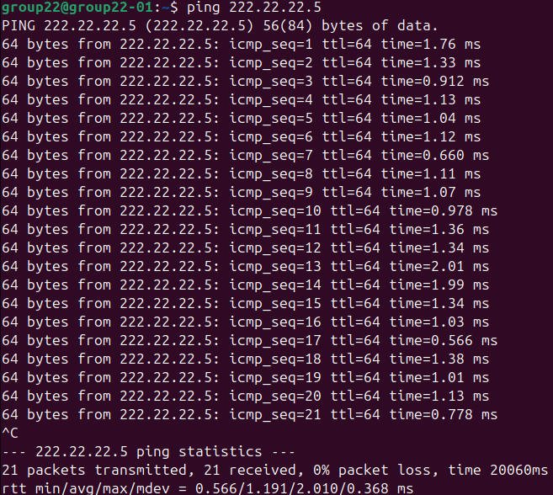

4.2.2 Ping group22-01 host from group22-02 host
ICMP Echo Requests are sent from group22-02 to the desktop IP 222.22.22.6. Successful replies confirm bidirectional communication between both hosts.
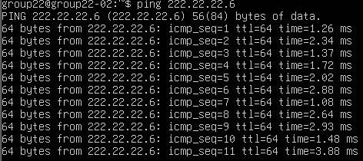

4.3 Test external connectivity using public hosts/web site using ping and traceroute

4.3.1 Ping a public host from group22-01 host
The desktop system successfully resolves www.google.com to an external IP address and receives ICMP Echo Replies with 0% packet loss. This confirms correct DNS resolution and outbound Internet connectivity through the NAT Network.
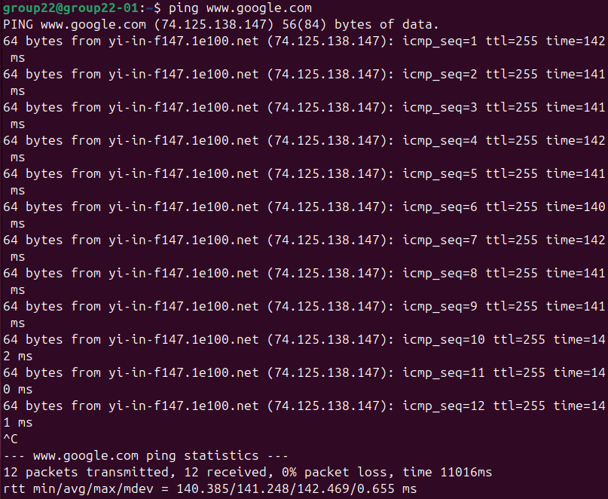

4.3.2 Run traceroute to a public host/web site from both hosts
Ubuntu Desktop
Traceroute shows the first hop as the NAT Network gateway 222.22.22.1, which represents the virtual router. Subsequent hops are not displayed due to ICMP filtering, which is common on public networks.

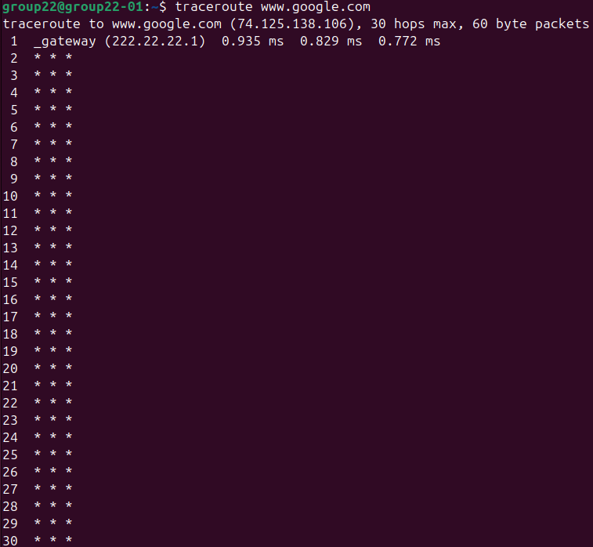

Ubuntu Server
Traceroute from the server produces similar results, confirming both systems use the same default gateway for external routing.
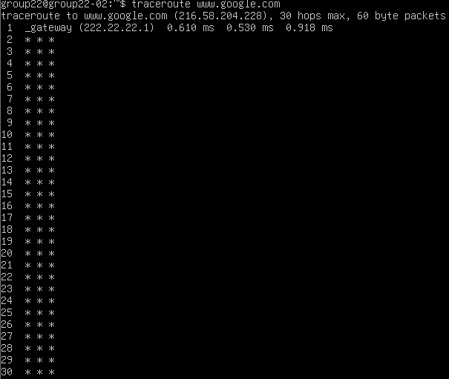

4.4 Perform DNS resolution using nslookup using public DNS server on your chosen hostname or web site
Ubuntu Desktop
A DNS query is sent to 8.8.8.8, and valid IPv4 and IPv6 addresses for www.google.com are returned. This confirms correct DNS operation.
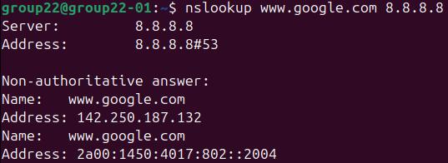
Ubuntu Server
The server performs the same DNS query and receives valid responses, demonstrating functional DNS resolution on both hosts.
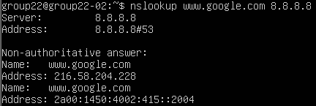

4.5 Use the OpenSSH client to connect remotely from Ubuntu Desktop to Ubuntu Server
An SSH connection is established from group22-01 to the server at 222.22.22.5. Authentication succeeds, confirming secure remote access functionality.
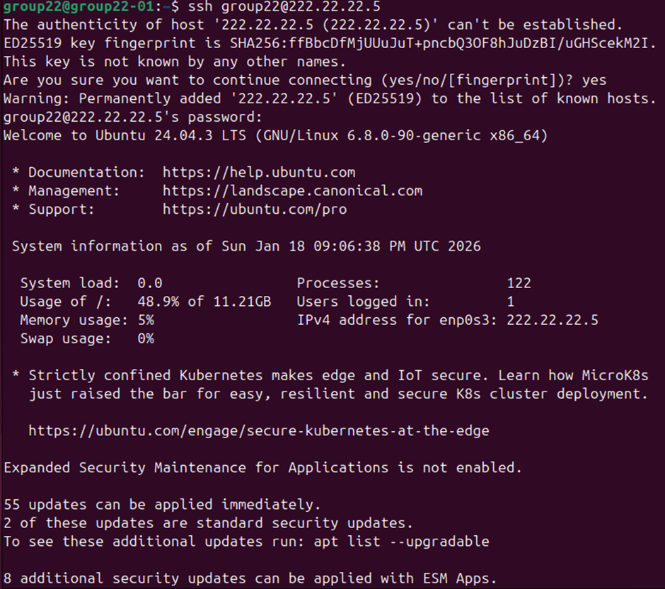
The login information confirms successful remote access and records the client IP address, demonstrating proper SSH session establishment.


4.6 Assign static IP addresses to both Ubuntu Desktop and Ubuntu Server and repeat steps 4.2 and 4.3
The Ubuntu Server network configuration is modified to disable DHCP and assign the static IP 222.22.22.10/24, with default gateway 222.22.22.1 and DNS servers 8.8.8.8 and 8.8.4.4.
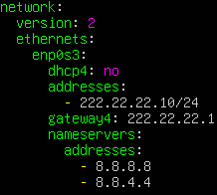
Verification confirms the server interface is assigned the static IP 222.22.22.10/24.
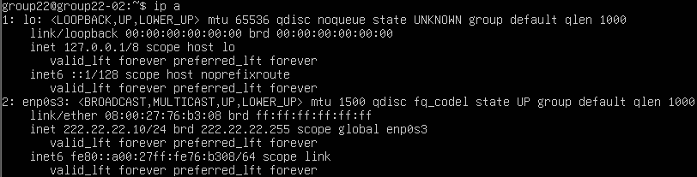

The Ubuntu Desktop network configuration is updated to use the static IP 222.22.22.11/24, with the same gateway and DNS servers.
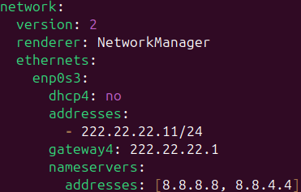
Verification confirms the desktop interface is assigned the static IP 222.22.22.11/24.
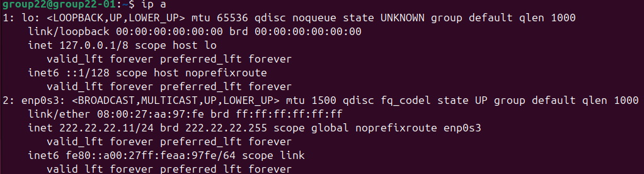
The file /etc/hosts on the Ubuntu Desktop maps 222.22.22.10 to the hostname group22-02, enabling local hostname resolution without DNS.
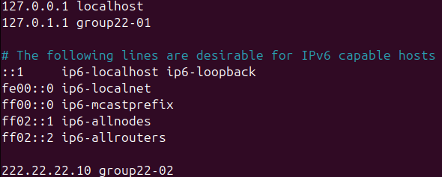
The /etc/hosts file on the Ubuntu Server maps 222.22.22.11 to group22-01, enabling mutual hostname resolution.
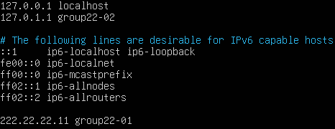
Ping tests using both IP addresses and hostnames succeed in both directions, confirming correct static addressing and hostname resolution.
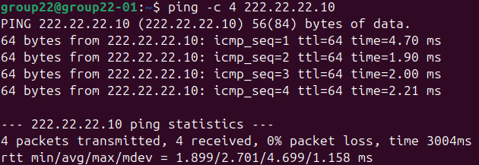
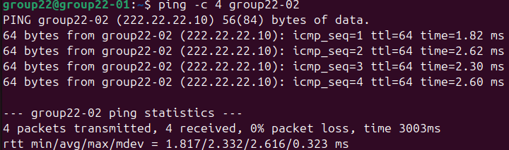
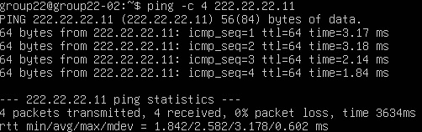
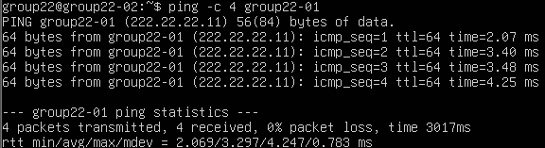

Ping and traceroute tests to public hosts remain successful, demonstrating that static IP configuration does not affect external connectivity.
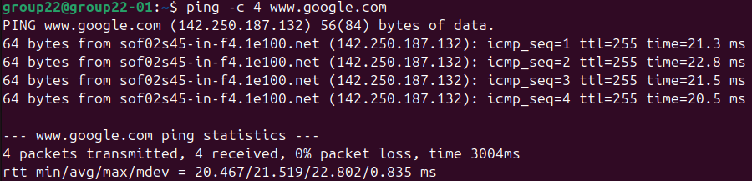
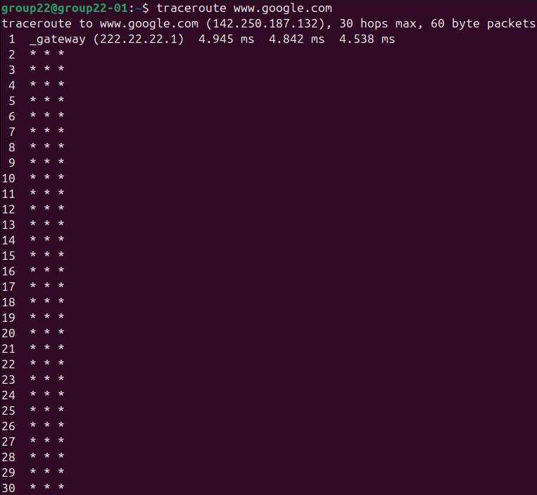
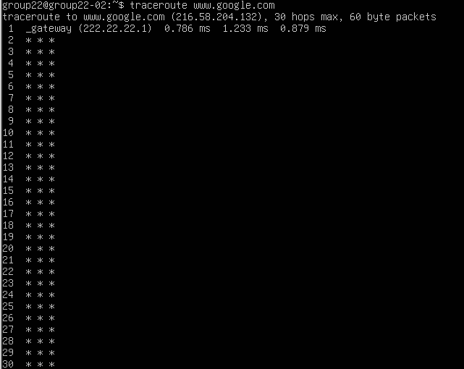

The Nginx service remains active after static IP configuration, confirming service stability.
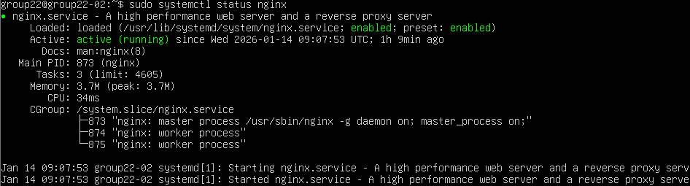

A local HTTP request using curl verifies that the web server is functioning correctly on the server system.
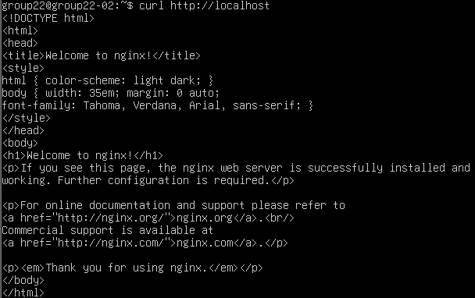

4.7 Map Ubuntu Server hostname with IP (simulate local DNS) on for Ubuntu Desktop on /etc/hosts configuration file
The /etc/hosts file on the Ubuntu Desktop was configured to map the Ubuntu Server’s IP address (222.22.22.10) to its hostname (group22-02). This simulates a local DNS resolution, allowing the server to be reached by hostname instead of IP within the virtual network.

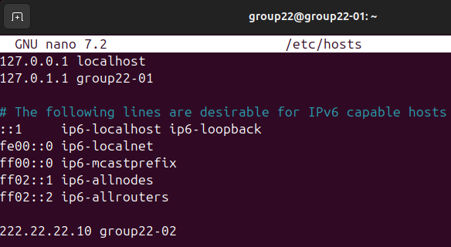
5

Test Client Server Applications

5.1 From Ubuntu Desktop, access the default Nginx/Apache web page on Ubuntu Server via IP or hostname
The Ubuntu Desktop browser accesses the web server using the hostname group22-02 and successfully displays the default Nginx page. Nginx functions as the web server, handling HTTP requests from the Ubuntu Desktop browser, while the browser operates as the HTTP client, receiving and rendering the server’s response.

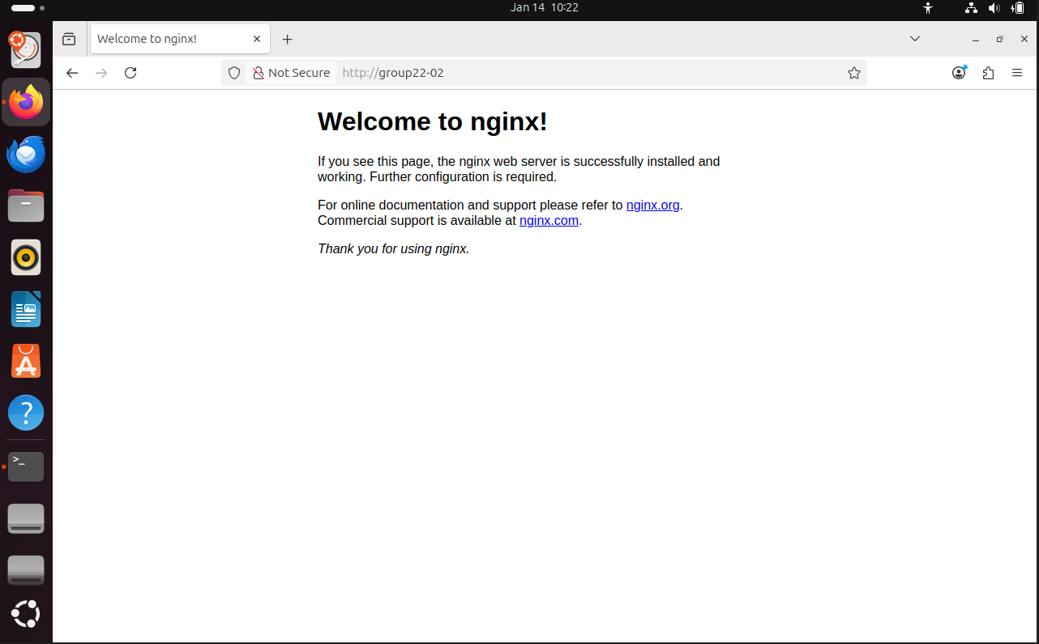

5.2 Use the OpenSSH client on Ubuntu Desktop to connect to the OpenSSH server on Ubuntu Server via IP or hostname
An SSH connection is successfully established using the static IP 222.22.22.10, confirming that secure remote access works consistently with static addressing.

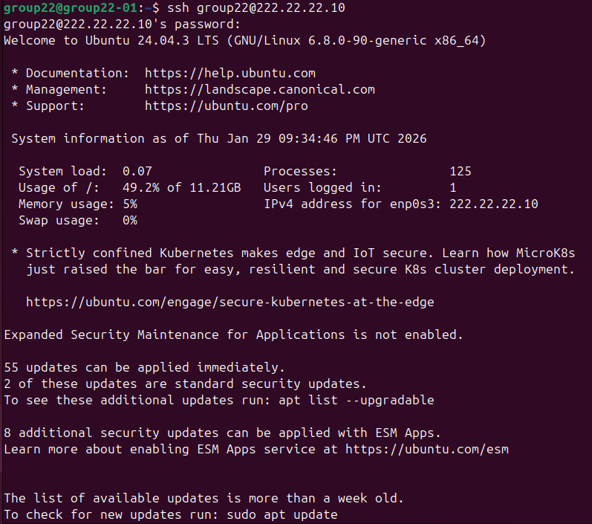

6

Install Networking Tools

6.1 On Ubuntu Server install:

6.1.1 net-tools
The net-tools package is installed, providing classic networking utilities such as ifconfig and netstat for interface and connection inspection.
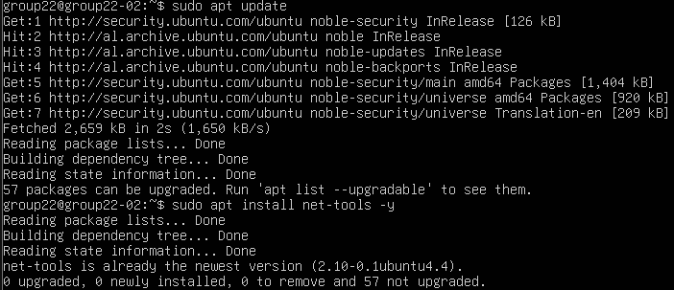

6.1.2 iperf3
The iperf3 service is enabled and running in server mode. This allows the system to accept throughput test connections from a client.
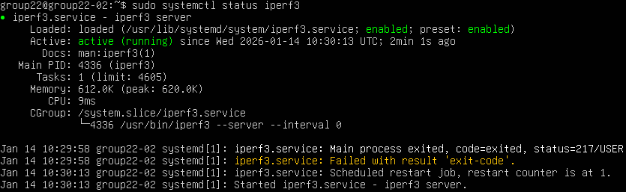

6.2 On Ubuntu Desktop install:

6.2.1 speedtest-cli
The speedtest-cli tool is installed to measure Internet throughput between the desktop system and an external speedtest server.
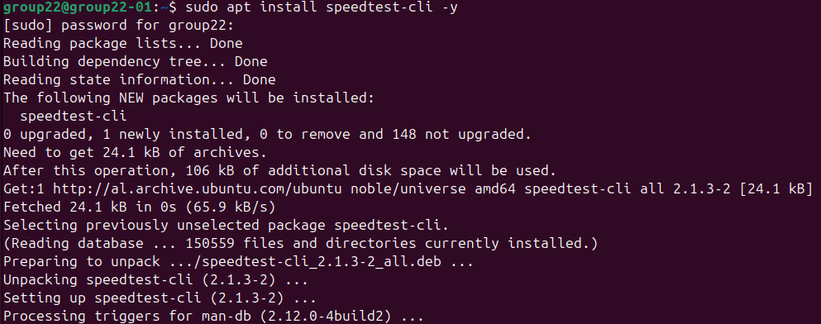

6.2.2 curl
The curl utility is installed, allowing HTTP requests to be sent from the command line for testing web services.
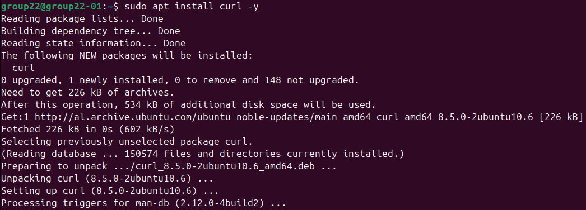

6.2.3 Wireshark
Wireshark is installed with all required dependencies, enabling packet capture and protocol analysis.
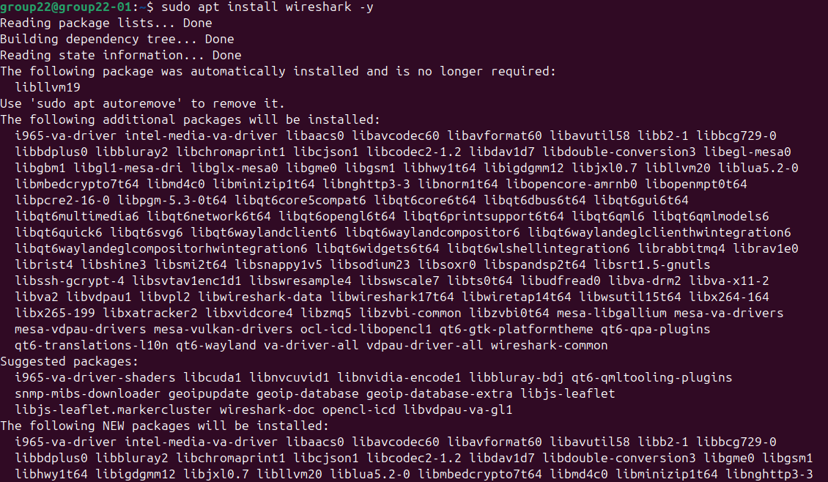
Wireshark is launched successfully, and the active network interface enp0s3 is available for packet capture.
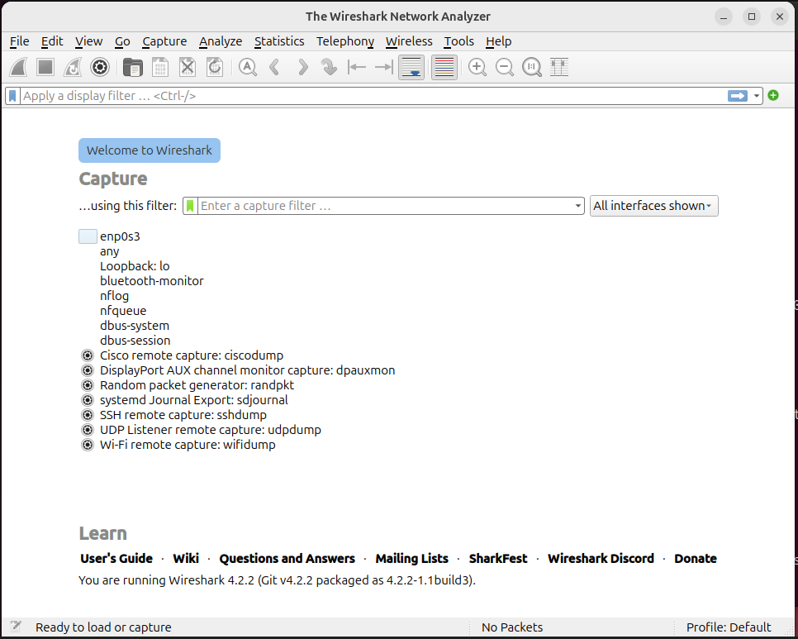
7

Measure Performance and Document Results

7.1 Measure throughput

7.1.1 Between Ubuntu Desktop and Speedtest.net server using speedtest-cli or web browser
Speedtest-cli measures Internet performance, reporting 51.48 Mbit/s download, 18.99 Mbit/s upload, and 49.614 ms ping to the selected test server. These values represent end-to-end throughput through the NAT Network and host Internet connection.
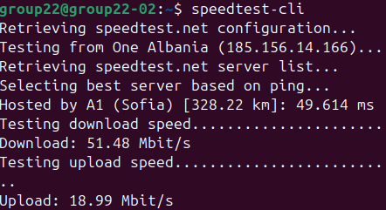

7.1.2 Between Ubuntu Desktop and Ubuntu Server using iperf3 or netperf
From the desktop, iperf3 measures throughput to the server at 222.22.22.10, achieving approximately 3.03 Gbits/sec, indicating high-speed local network performance.
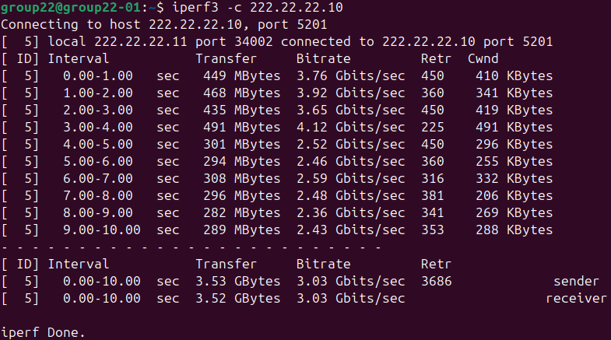
From the server, iperf3 measures throughput to the desktop at 222.22.22.11, achieving approximately 2.65 Gbits/sec, confirming consistent bidirectional LAN performance.
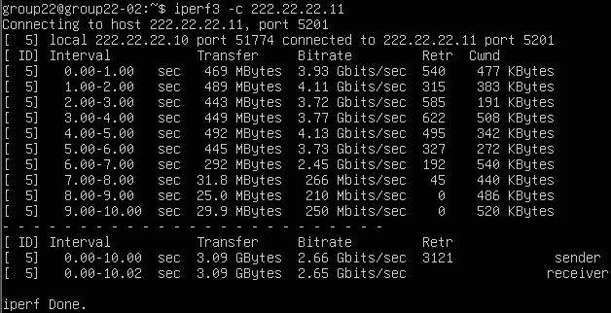

7.2 Measure Round Trip Time (RTT):

7.2.1 Between Ubuntu Desktop and Ubuntu Server
Ping measurements show an average round-trip time of approximately 1.236 ms, reflecting very low latency within the local virtual network.
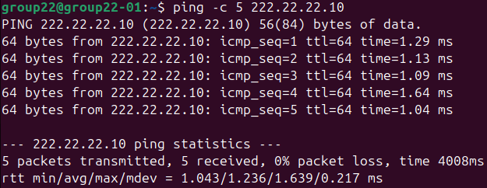

7.2.2 Between both hosts and a chosen public host
Ping from the desktop to a public host reports an average RTT of approximately 23.554 ms, representing Internet latency.
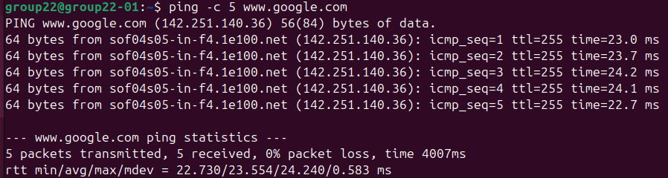
Ping from the server reports an average RTT of approximately 15.090 ms, demonstrating normal variation due to routing and DNS resolution.
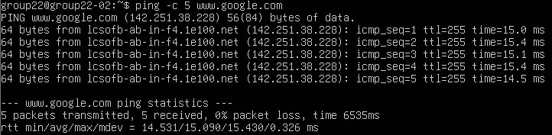

7.3 Use Wireshark to capture:

7.3.1 HTTP request/response packets between Ubuntu Desktop and Server
Wireshark captures HTTP GET requests from 222.22.22.11 to 222.22.22.10 and corresponding HTTP/1.1 200 OK responses, confirming successful application-layer communication between client and server.
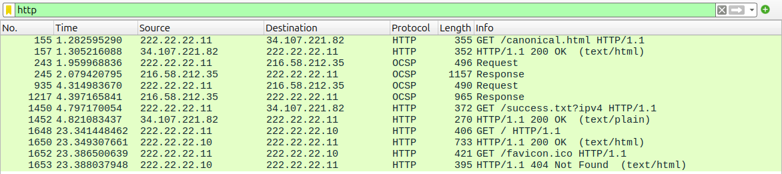

7.3.2 DNS packets between Ubuntu Desktop and your chosen public website
DNS packets show queries from 222.22.22.11 to 8.8.8.8 for www.google.com, followed by valid DNS responses, confirming correct DNS operation.
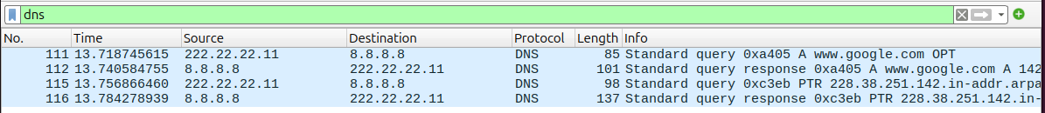

7.3.3 A TCP three-way handshake between Ubuntu Desktop and Server
Wireshark captures the TCP three-way handshake consisting of SYN, SYN-ACK, and ACK packets between the desktop and server on TCP port 80, demonstrating proper connection establishment before HTTP data transfer.
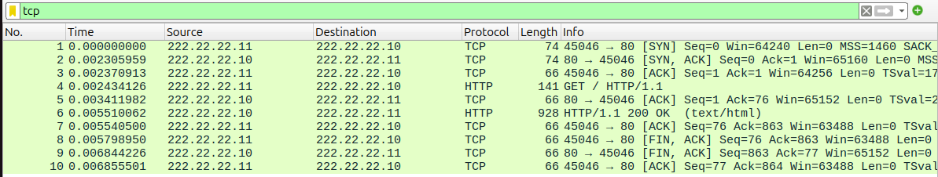

7.4 Use curl on Ubuntu Desktop to send an HTTP GET request to the Nginx/Apache server on Ubuntu Server
A curl HTTP GET request to http://222.22.22.10 successfully retrieves the default Nginx HTML page. Curl acts as an HTTP client, and Nginx responds as the HTTP server over TCP port 80.
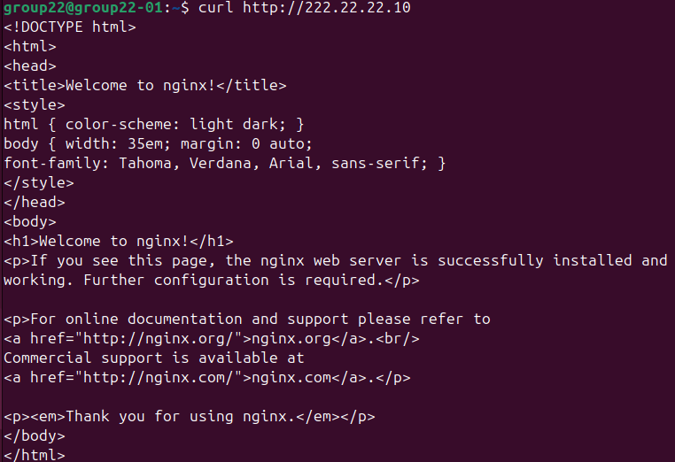

8

Document the Project

8.1 For each task, explain concepts and terms from Computer Networks
Application Layer – User and Service Interaction
The Application Layer is responsible for providing network services directly to users and applications.
- Nginx / Apache Web Server
Nginx (and alternatively Apache) operates at the Application Layer as a web server. It handles HTTP requests sent by the client and returns HTTP responses containing web content. In this project, Nginx functions as the server-side application, while the client initiates communication using HTTP.
- Google Chrome / Mozilla Firefox
Web browsers act as HTTP clients. They generate HTTP GET requests, send them to the web server, and interpret the received HTTP responses for display.
- OpenSSH Server and OpenSSH Client
The OpenSSH server provides secure remote access services, while the OpenSSH client initiates encrypted connections. Together, they enable secure command-line communication between client and server using the SSH protocol.
- DNS and nslookup
DNS operates at the Application Layer by resolving domain names into IP addresses. The nslookup tool is used to query DNS servers and verify correct name resolution.
- curl
Curl is a command-line HTTP client used to send HTTP requests directly to the web server, demonstrating application-layer communication without a graphical browser.
Transport Layer – Reliable and Secure Data Delivery
The Transport Layer ensures reliable communication between applications running on different hosts.
- TCP (Transmission Control Protocol)
TCP is used by HTTP and SSH to provide reliable, ordered, and error-checked data transmission. Before data transfer begins, TCP establishes a connection using the three-way handshake.
- TCP Three-Way Handshake
The handshake consists of SYN, SYN-ACK, and ACK packets. This process synchronizes sequence numbers and confirms that both endpoints are ready to communicate.
- iperf3
Iperf3 measures Transport Layer performance by generating TCP traffic between client and server to evaluate throughput and retransmissions.
Network Layer – Logical Addressing and Routing
The Network Layer is responsible for logical addressing and packet forwarding between networks.
- IP Addressing
Each device is assigned an IP address to uniquely identify it within the network. Both dynamic (DHCP) and static IP addressing are used to demonstrate flexible and fixed network configurations.
- NAT Network
Network Address Translation allows multiple virtual machines with private IP addresses to access external networks using a single public address. The NAT Network acts as a virtual router and gateway.
- Router (Default Gateway)
The router forwards packets between the local subnet and external networks. It determines the best path for packet delivery outside the local network.
- Traceroute
Traceroute reveals the path packets take through the network by manipulating the IP Time-To-Live (TTL) field, helping analyze routing behavior.
Link Layer – Local Network Communication
The Link Layer handles communication between devices on the same physical or virtual network.
- Switch
The switch forwards Ethernet frames based on MAC addresses, enabling communication between hosts within the same local network.
- Ethernet Interfaces
Virtual network interfaces emulate physical network cards and allow devices to send and receive frames over the local network.
Cross-Layer Tools and Performance Metrics
Some tools and concepts provide insight across multiple layers rather than belonging to a single one.
- Ping and RTT (Round Trip Time)
Ping uses ICMP to test reachability and measure RTT, reflecting network responsiveness and latency.
- Wireshark
Wireshark captures and analyzes packets from multiple layers simultaneously, including DNS queries, HTTP traffic, and TCP handshakes. It provides visibility into how protocols interact across the stack.
- DHCP (Dynamic Host Configuration Protocol)
DHCP automates IP configuration, bridging the Application and Network Layers by dynamically providing IP addresses, gateways, and DNS information.

8.2 Include screenshots to document all configurations and tests
Done ✔️

8.3 Use Cisco Packet Tracer to illustrate your network topology, including router, switch, and end-host configurations
Cisco Packet Tracer was used to illustrate the network topology implemented in this project. The simulated topology represents a simple local area network composed of a client, a server, a switch, and a router.
The topology consists of three main components:
- End Hosts
  - PC-PT (group22-01): Acts as the client machine. It represents a user workstation that initiates network communication, such as sending requests to the server.
  - Server-PT (group22-02): Acts as the server machine. It represents a service provider within the network, responding to client requests (e.g., web or SSH services).
- Switch
  - 2960-24TT (Switch-group22): Functions as a Layer 2 device that interconnects the end hosts within the same local network. It forwards Ethernet frames based on MAC addresses and enables direct communication between the PC and the server.
- Router
  - 2911 (Router-group22): Acts as the default gateway for the local network. It connects the LAN to external networks and enables routing beyond the local subnet.
All devices are connected using Ethernet links, and the active link indicators confirm correct physical and logical connectivity. This topology clearly demonstrates the interaction between end hosts, switching, and routing components, and supports the overall network design presented in this project.

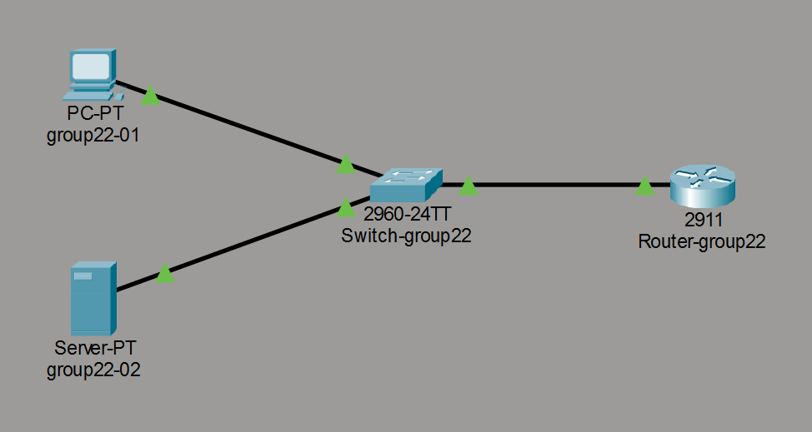
9

Final Conclusion
This project successfully demonstrated the design, configuration, and evaluation of a virtual network implementing a client–server architecture using VirtualBox. A dedicated NAT Network with the subnet 222.22.22.0/24 was configured to simulate a private Local Area Network (LAN), enabling controlled communication between virtual hosts while preserving external connectivity through Network Address Translation (NAT).
Two Linux-based systems were deployed with clearly defined roles: Ubuntu Server (group22-02) as the service provider and Ubuntu Desktop (group22-01) as the client. Network configuration included dynamic IP addressing via DHCP, static IP assignment, DNS configuration, and local hostname mapping, ensuring consistent host identification and reliable communication. Connectivity and routing were verified using ping (ICMP), traceroute, and nslookup, confirming correct functionality at the Network and Transport layers.
Application-layer services were installed and tested to validate real client–server interaction. Nginx Web Server operated as the HTTP server, handling HTTP request/response exchanges initiated by the web browser and curl acting as HTTP clients. Secure remote administration was achieved using the OpenSSH Server and OpenSSH Client, providing encrypted communication over TCP.
Network performance and behavior were evaluated using standard measurement and analysis tools. iperf3 was used to measure local network throughput, while speedtest-cli assessed external Internet performance through the NAT environment. Round Trip Time (RTT) measurements highlighted the low latency of local communication compared to higher and variable latency when communicating with public hosts. Additionally, Wireshark was used to capture and analyze network traffic, including DNS resolution, HTTP traffic, and the TCP three-way handshake, directly linking theoretical concepts to packet-level evidence.
Finally, Cisco Packet Tracer was used to visually illustrate the logical network topology, including the router, switch, and end hosts, reinforcing the overall network design and providing a clear conceptual representation of device roles and connectivity. Overall, this project effectively integrated theoretical concepts from Computer Networks (CEN 307) with hands-on implementation, demonstrating how layered network communication is designed, deployed, tested, and analyzed in a controlled virtual environment.

